**＜Query5＞**

**From:** Entity3-Ops-Reset

**Sent:** Friday, 25 December 2023 00:00

**To:** Entity1-MO-FX

**Cc:** Entity3-Ops-Reset

**Subject:** No BFIX rate to be published

Hi,

We see the below trades requiring BFIX TOK 15 fixing for today, please advise as BFIX rates will not be published today.

|  |  |  |  |  |  |  |  |  |  |  |  |  |  |  |  |  |
| --- | --- | --- | --- | --- | --- | --- | --- | --- | --- | --- | --- | --- | --- | --- | --- | --- |
| TS36418444 | EXSD NFPS | BFIX(TOKYO) @ 15:00 | USDJPY | 24Dec2020 | 103.5650 | FDC | 31Mar2021 | USDJPY | Buy | 50150000 | USD | 107.5000 | 0.0100 | 10000000 | IHIM-TKY-NSC | SCRD |
| TS36418434 | EXSD NFPS | BFIX(TOKYO) @ 15:00 | USDJPY | 24Dec2020 | 103.5650 | FD | 31Mar2021 | USDJPY | Buy | 50150000 | USD | 107.5000 | 0.0100 | 10000000 | IHIM-TKY-NSC | SCRD |

Thanks and Regards,

Entity3-Ops-Reset

**＜Answer5＞**

**From:** Entity1-MO-FX-1

**Sent:** Friday, December 25, 2023 12:34

**To:** Entity1-Trader-FX-1; Entity1-Trader-FX-2; Entity1-Sales-FX-1

**Cc:** Entity3-Ops-Reset; Entity2-MO-FX; Entity1-MO-FX; Entity1-SS-FX

**Subject:** <Pls Advise> RE: No BFIX rate to be published

Hi Entity1-Trader-FX-1 and Entity1-Trader-FX-2,

BFIX rate is not published today.

Could you please kindly advise the rate to be used for fixing on the below trade?

As per the contract, we are the calc agent who is to determine the rate when BFIX is not available.

BFIX holiday notice for reference:

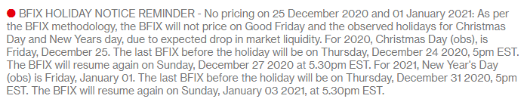

Entity1-MO-FX-1